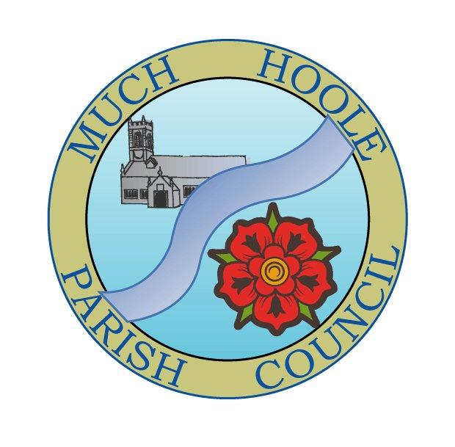 | MUCH HOOLE PARISH COUNCIL  NOTICE OF MEETING
You are hereby summoned to attend the Meeting of Much Hoole Parish Council to be held on Monday 9th November 2020. The meeting will be held remotely via Zoom video technology under the provisions of the emergency Coronavirus legislation.

In the interests of transparency of Council business, the agenda is printed below. Any member of the public who wishes to comment or have their views heard at the meeting should contact the Clerk by email as follows: clerk@muchhoolepc.org.uk

Russ Weaver, Clerk to the Parish Council

AGENDA
1. | Apologies for Absence  To receive apologies for absence.
2. | Declaration of Interests and Dispensations  - To receive declarations of interest from Councillors on items on the agenda  - To receive written requests for dispensations for disclosable pecuniary interests (if any)  - To grant any requests for dispensation as appropriate
3. | Minutes of the Previous Meeting  To resolve to approve as a correct record the Minutes of the Council Meeting held on 12th October 2020
4. | Public Time  The published agenda contains an opportunity for members of the public to raise any general concerns or issues in relation to items under discussion via the Clerk. Any such contact from members of the public will be dealt with at this item. Anyone wishing to join the meeting should email the Clerk on clerk@muchhoolepc.org.uk and login details will be provided to enable you to join.
5. | Off Road Cycle Track  To consider any updates on the Cycle track and resolve any actions required.
6. | Village Hall Update  - To receive an update on progress towards completion of a new village hall
7. | Finance  To resolve to note and / or authorise payment of the following:  - To resolve to pay Royal British Legion invoice for poppy wreath in sum of £26  - To resolve to pay Clerk salary for October 2020 in sum of £220 (net)  - To resolve to pay Clerk mileage in sum of £7.20 (miles in Sept & October)  - To resolve to pay HMRC PAYE for October 2020 in sum of £55.00  - To resolve to re-imburse Cllrs C and T Hewitt with personal costs incurred in their organization of the Halloween competition in the sum of £100, The Council had agreed to support this competition in principle at the last meeting.
8. | Governance issues  - To approve Standing Orders for the Parish Council  - To approve Financial regulations for the Parish Council  - To note changes to, and approve amended risk register (changes relate to safeguards for payments to village hall and internet banking procedures)  - To approve asset register
9. | Community Projects update  - To receive an update on any community project plans or spending  - To resolve to commit a sum of £150 to support a Parish Council Christmas competition along the same lines as the Halloween competition  - To resolve to purchase two Christmas Trees to be sited at the Village Hall and the Recreation ground at a cost within the agreed budget figure set for 2020-21
10. | Planning items  07/2020/00682/VAR  October 5, 2020  Variation of condition 2 (Approved plans) pursuant to planning permission  07/2020/00277/FUL for erection of 14 no: bungalow for over 55 age group to allow for  removal, and replacement a tree (T9) adjacent the Knoll Lane boundary to further assist the  formation of the approved construction access from Knoll Lane. Land Off Oldfield and Long Meadow  Oldfield Much Hoole Lancashire  07/2020/00814/NMA October 2, 2020 Alterations to plots 2 and 3 design and scale  4 Lunds Lane Much Hoole Preston Lancashire PR4 4GJ  Mr Ray Greenhalgh  Green Bank House  Wigan Road  Clayton-le-Woods  PR25 5SB  07/2020/00869/DIS October 21, 2020 Discharge of conditions 4 (structural  appraisal)and 5 (heritage assessment) imposed on planning approvals  07/2018/4271/FUL Church Farm Liverpool Old Road Much Hoole Preston Lancashire  PR4 4QA  Mr Giles Bracewell  Church Farm  Liverpool Old Road  Much Hoole  Preston PR4 5JQ  United Kingdom
11 | Reports from meetings  - To note LALC accounts for forthcoming AGM  - To receive reports from any relevant meetings attended by Councillors
12. | Items for the Next Agenda (for information only)  Budget and precept setting for 2021-2022
13. | Date of Next Meeting  The Parish Council to agree the date of the next meeting as 7.30pm Monday 14th December 2020 (format will be subject to prevailing Govt guidance)

